Copying Sample Interest Group & Task Group Page Folders

Sample folders have been created for Interest Groups & Task Groups. When you want to add a new folder, these folder sets can be copied and then configured for a specific group.

# Set User Permissions

First, make sure the user has permission to copy page sublevels. If permission has already been granted, skip to the next section.

1. Click on “User Settings” in the left-hand menu

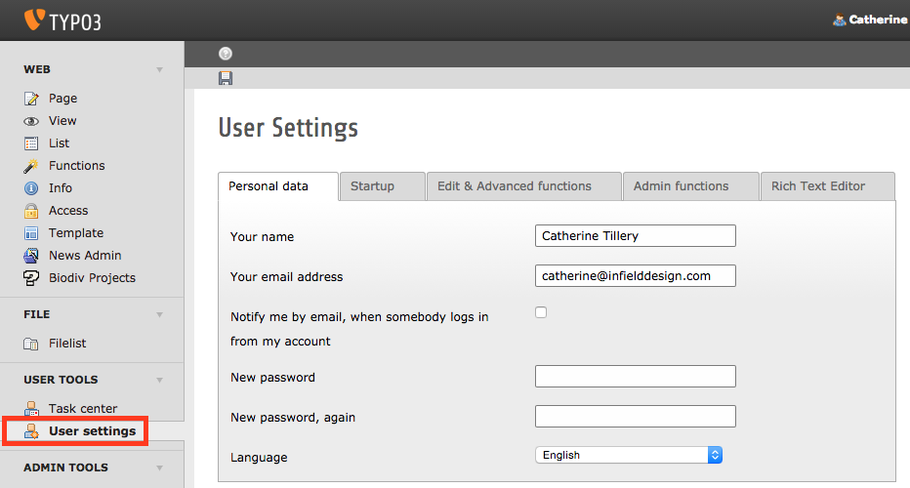

1. Click on the “Edit & Advanced Functions” tab
2. Enter “10” in the “Recursive Copy” field. The sample folders have 7 subpages, so setting the quantity to 10 should suffice. It can always be changed if additional subpages are added.
3. Click “Save”

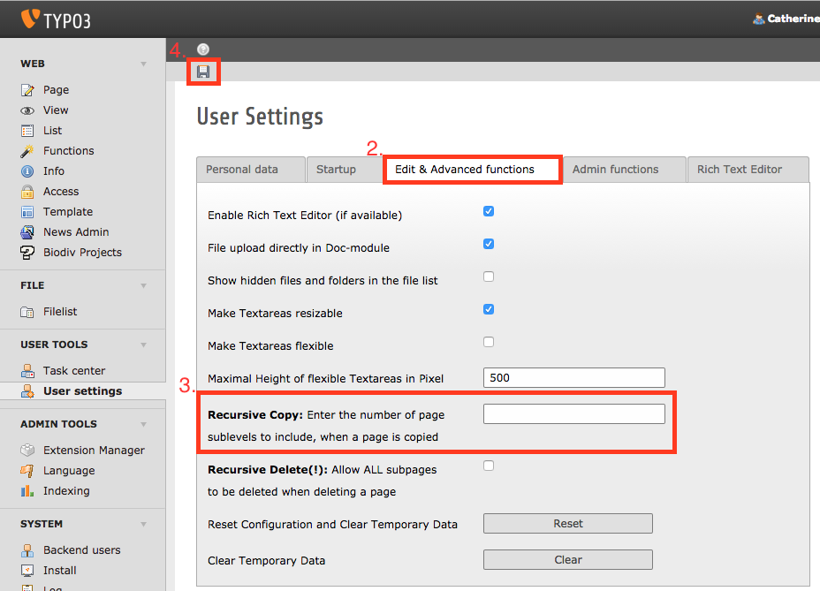

1. Log out and log back in to activate the changes.

# 

# 

# Copy the Folder

1. Click on “Page” in the left-hand menu
2. Right-click on the Sample Group folder to open the menu
3. Hover over “Page Actions” and click “Copy”

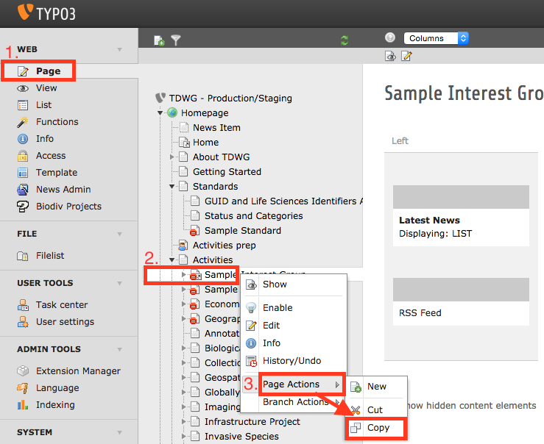

1. Find the folder after which you want to add the new folder.
2. Right-click on the folder to open the menu
3. Hover over “Page Actions” and click “Paste After”

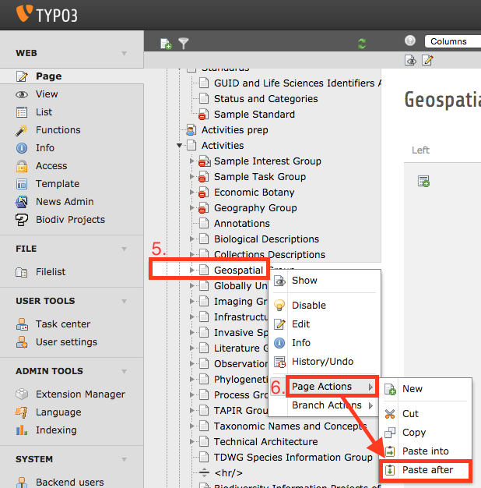

1. Your new folder will be created, with it’s subpages. Name the folder and configure the group as necessary.

